Database Systems Lab work
Week 2: Relational Model & Keys
Name: Kuanyshbai Aruzhan

Part 1
Task 1: Relation A
1. Superkey:
1(EmpID, SSN) 2(Email,phone) 3(Name, deparment)
4(Phone, SSN) 5(EmpID, salary) 6(Email, name)
2. Candidate key:
1 – EmpID 3 – Phone
2 – SSN 4 – Email
3. EmpID can be the primary key because it is unique for each employee and does not change. SSN can also be unique, but EmpID is usually better because it is specifically created to identify employees.
4. No. Based on the data shown, no two employees have the same phone number. Each employee has a unique phone number
Relation B:
StudentID is necessary because it identifies the student who is registering.
CourseCode is necessary because it identifies the course.
Section is necessary because a course can have multiple sections.
Semester is necessary because a student can take the same course in different semesters. All four attributes are necessary to uniquely identify a registration.
3.Answer: There are no additional candidate keys based on the given business rules. The candidate key is {StudentID, CourseCode, Section, Semester} because all four attributes are necessary to uniquely identify a registration.
Task 1.2:
Course.DepartmentCode -> Department.DeptCode
Enrollment.StudentID -> Student.StudentID
Enrollment.CourseID -> Course.CourseI

Task 2.2:
1.Strong – Patients, Doctors, Departments, Appointments, Prescriptions
Weak – Hospital Rooms

2. Patients: 3. Doctors:
- PatientID – Primary key, simple - DoctorID – Primary key, simple
- Name – simple - Name – simple
- Birthdate – simple - Specialization – multi-valued
- Address – composite: (street,city,state,zip) - PhoneNumber – simple
- PhoneNumber – multi-valued - OffLocation – simple
- Insurance – simple

3. Departments:
-DepartmentCode – Primary key
-Name – simple
-Locations - simple
-Purpose – simple
- Notes - Simple

4. Appointments:
AppID – Primary key
-DoctorName – Simple
-Date - Simple

5. Prescriptions:
-PrescriptionsID – Primary key -RoomNumber - partial key
-Medications – simple - DepartmantCode – Foreign key
- Patients – simple
- Dosage – simple
- Instructions – simple

6. Hospital Rooms:

-RoomNumber - partial key
-Medications – simple - DepartmantCode – Foreign key

3. 1 : 1 – we dont have this type relations
1 : N – Patient->Appointment, Doctor->Appointment, Doctor-> Prescriptions,
Patient-> Prescriptions, Department->HospitalRooms
Patient N:M Doctor (with Appointment)
4. 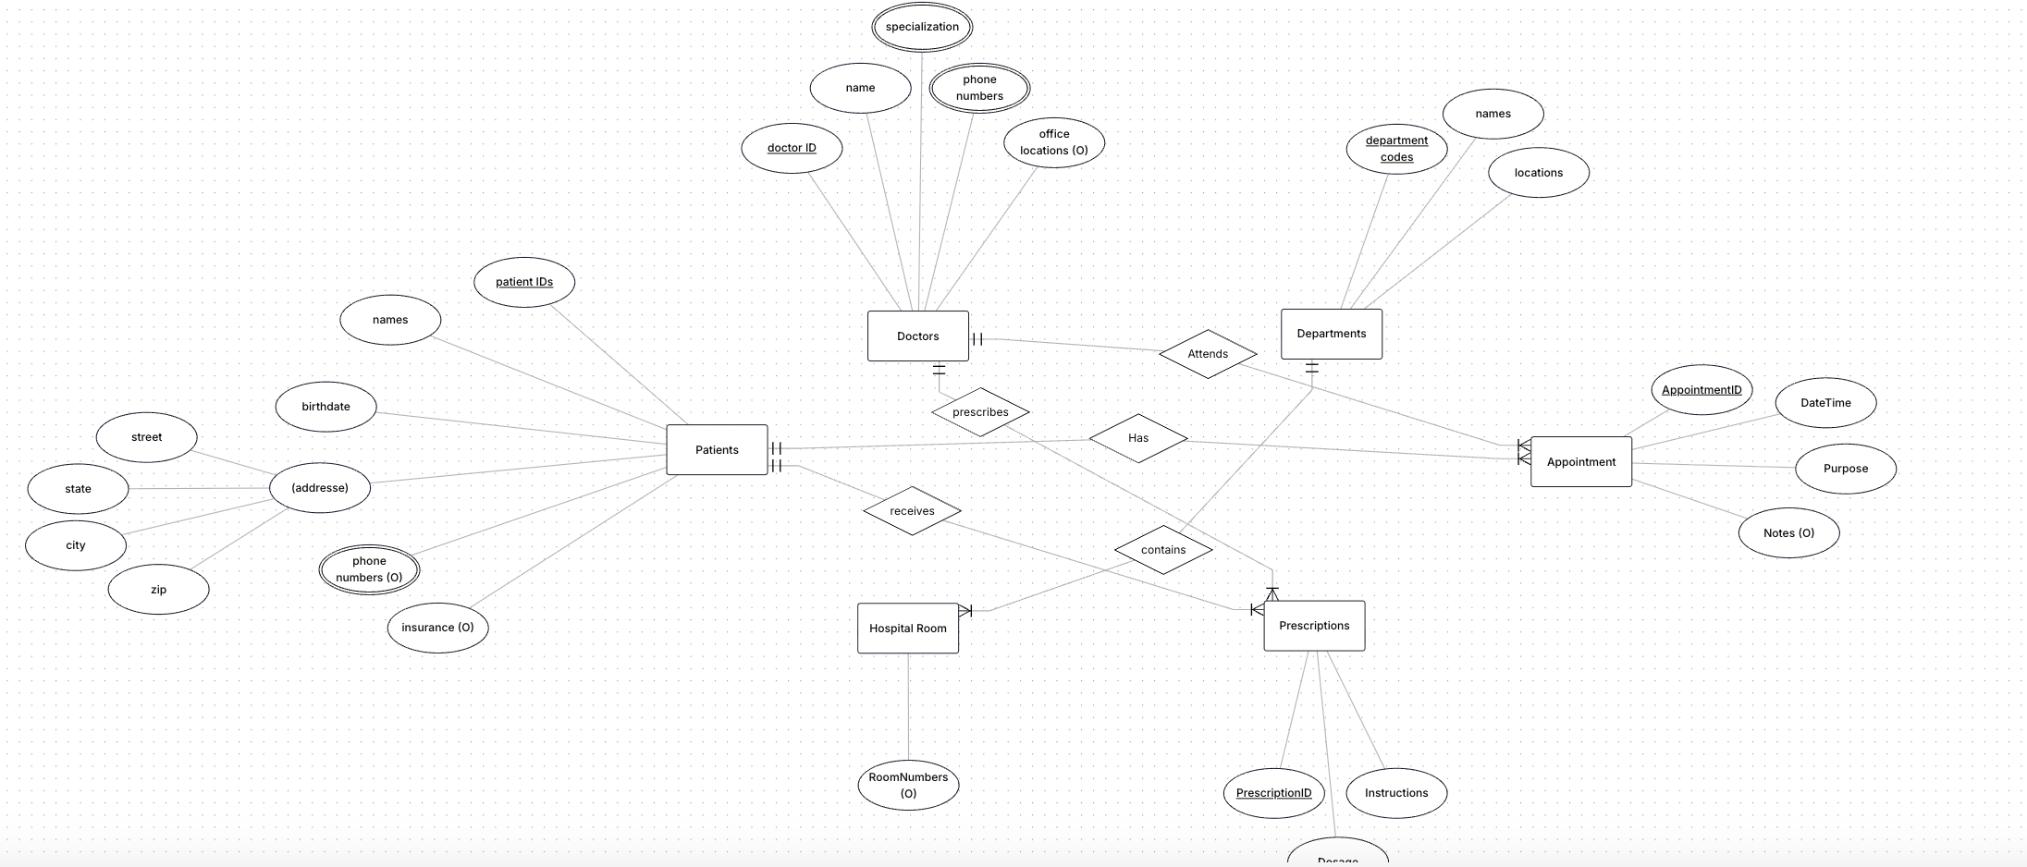

5. Pk are marked with underline

Task2.2
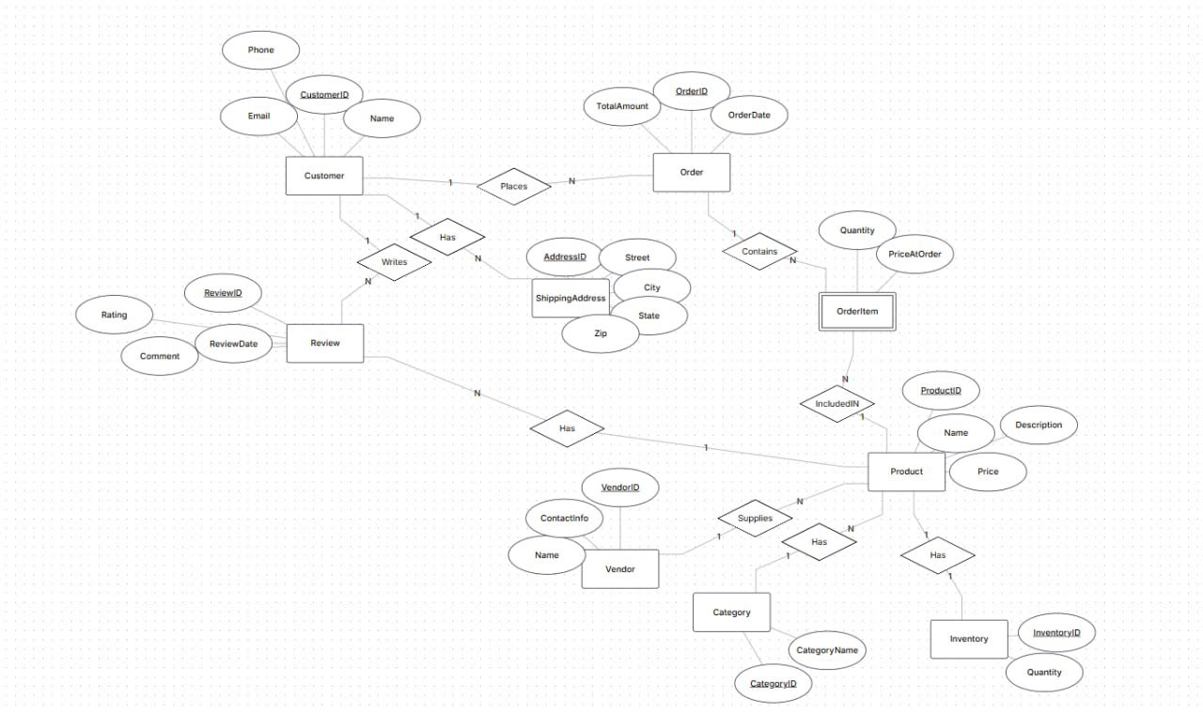
Part 4;
1. StudentID -> StudentName,StudentMajor
ProjectID -> ProjectTitle, ProjectType

SupervisorID -> SupervisorName, SupervisorDept

StudentProject (StudentID, ProjectID) -> Role, HoursWorked, StartDate, EndDate

2. redundancy:
- Name and major of student are repeated for each project

- The name and department of the supervisor are repeated for each student working on
the project.

3. Anomalies:
Update: If the head’s department changes, all lines where it appears need to be
updated.

Insert: You cannot add a new student without a project, as the ProjectID is
mandatory.

Delete: If you delete the last entry about the project, you will lose information
about the project itself and its leader.

3) The table is already in 1NF. (all values are atomic)

4) Primary Key: (StudentID, ProjectID)

Partial dependences:
StudentID -> StudentName,Student Major

ProjectID -> ProjectTitle, ProjectType

SupervisorID -> SupervisorName, SupervisorDept

2nf: Student (StudentID, StudentName, StudentMajor)
Project (ProjectID, ProjectTitle, ProjectType, SupervisorID)

Supervisor (SupervisorID, SupervisorName, SupervisorDept)

StudentProject (StudentID, ProjectID, Role, HoursWorked, StartDate, EndDate)

5. transitive depences: Project: SupervisorID-> SupervisorName, SupervisorDept (with
SupervisorID)

3nf:
Student (StudentID, StudentName, StudentMajor)
Project (ProjectID, ProjectTitle, ProjectType, SupervisorID)

Supervisor (SupervisorID, SupervisorName, SupervisorDept)

StudentProject (StudentID, ProjectID, Role, HoursWorked, StartDate, EndDate)

Task 4.2:
1)Primary Key (StudentID, CourseID, TimeSlot, Room)

2) from Business Rules:
StudentID -> StudentMajor CourseID -> CourseName
InstuctorID->Instructor Name Room -> Building

(CourseID, TimeSlot, Room) -> InstructorID

(StudentID, CourseID, TimeSlot, Room) -> all other attributes (this is the key).

3) BCNF — every determinant must be a superkey

StudentID → StudentMajor (StudentID is not a key).

CourseID → CourseName (CourseID is not a key).

InstructorID → InstructorName (InstructorID is not a key).

Room → Building (Room is not a key ).

Table is not BCNF

4) Decompose to BCNF

Students(StudentID, StudentMajor)

Courses(CourseID, CourseName)

Instructors(InstructorID, InstructorName)

Rooms(Room, Building)
CourseSections(CourseID, TimeSlot, Room, InstructorID)

Enrollments(StudentID, CourseID, TimeSlot, Room)

5)
There is no data loss, but there is a need to join tables via JOIN to obtain the
original information. For example, to find out a student’s schedule, you need to join Enrollments with CourseSections, and then with Courses, Instructors, and Rooms

